**Day 6 : HTML Tables: Structuring Data 📊**

HTML tables are used to display **tabular data**—information that is best organized into a grid of rows and columns, like a spreadsheet. While they were once used for page layout, this is now considered a bad practice. Their true purpose is to structure data.

**Core Table Structure**

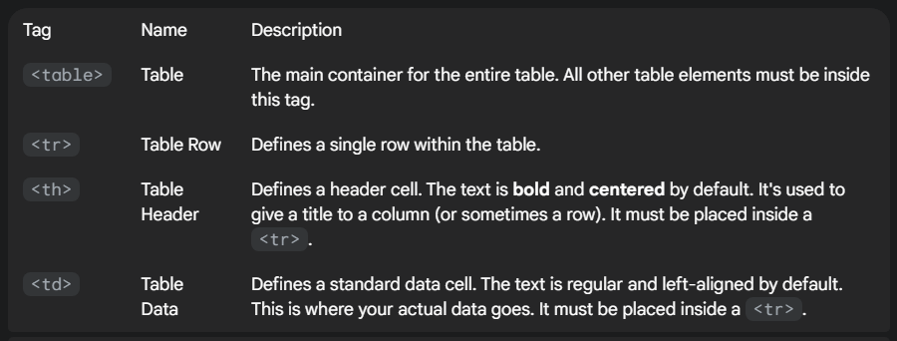A table has a clear, hierarchical structure.

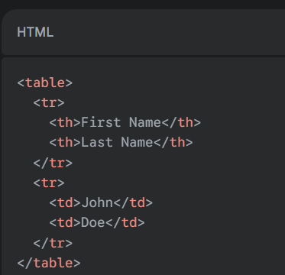**Exmple :**

This will create a simple 2x2 table.

**Semantic Grouping Tags**

For more complex tables, it's a best practice to group your rows into logical sections. These tags help with accessibility and styling and provide a clearer structure.

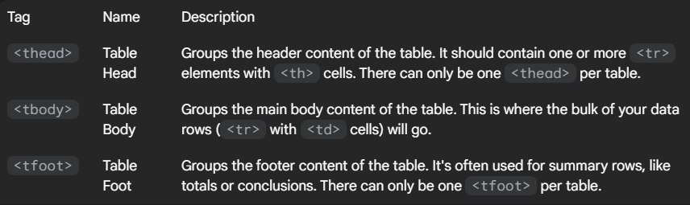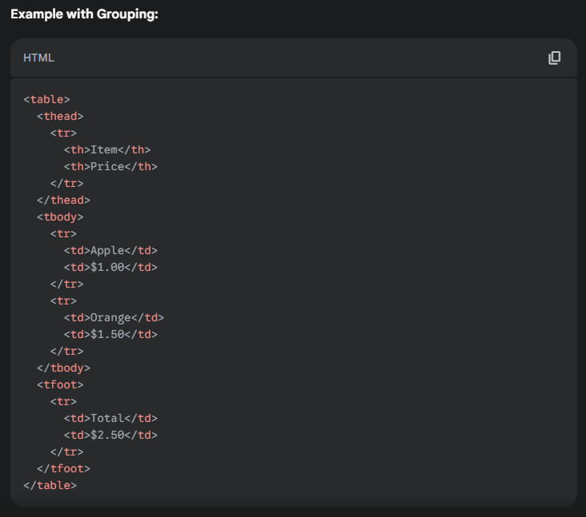

**Table Caption**

The <caption> tag provides a title or description for the entire table.

* It must be placed immediately after the opening <table> tag.
* It is crucial for accessibility, as it gives context to screen readers before they read the cell data.
* A table can only have one <caption>.

**Example Using colspan and rowspan:**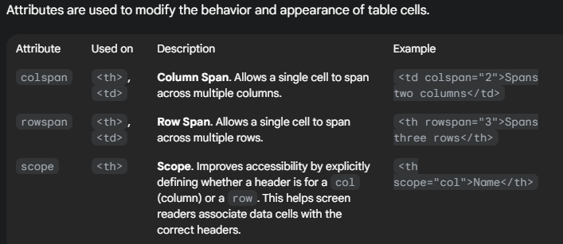

<table>

<caption>Employee Schedule</caption>

<thead>

<tr>

<th rowspan="2">Employee</th>

<th colspan="2">Shift</th>

</tr>

<tr>

<th>Morning</th>

<th>Afternoon</th>

</tr>

</thead>

<tbody>

<tr>

<td>Alice</td>

<td>9am - 1pm</td>

<td>1pm - 5pm</td>

</tr>

<tr>

<td>Bob</td>

<td colspan="2">9am - 5pm (Full Day)</td>

</tr>

</tbody>

</table>